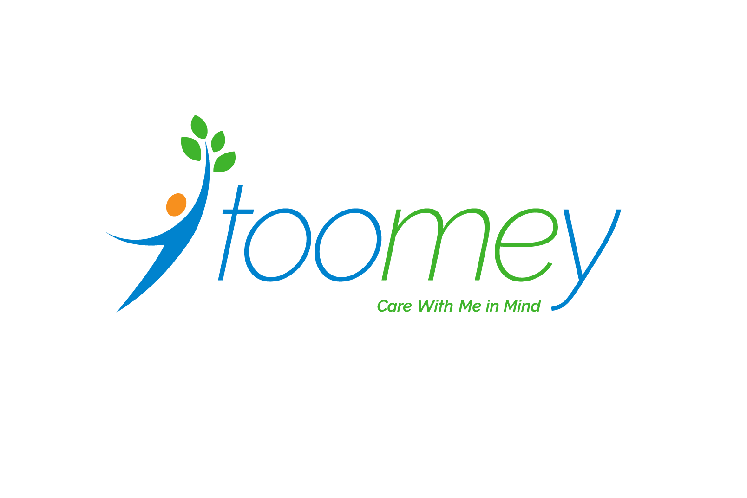

Toomey Residential and Community Services

Developmental Disabilities Support Services Quality Improvement Plan
Quality Improvement Department
Toomey Residential and Community Services | 1864 West Onondaga St., Syracuse, NY
TRACS QI Plan Table of Contents
Introduction and Purpose 3
Introduction 3
Organizational Structure 3
Purpose 5
TRACS Quality Improvement System 6
Roles and Responsibilities 6
Quality Improvement Department 6
Compliance Department 6
TRACS Leadership 6
Quality Improvement Committee 6
TRACS Board 6
TRACS Staff 6
Annual Timeline 7
Key DDSS Quality Indicators 7
Bureau of Program Certification Reviews 7
Internal Audits 8
Quality of life and satisfaction of individual’s served by TRACS 9
Quality and satisfaction levels of TRACS staff 11
Staffing capacity, recruitment, and retention 12
Summary of 2026 QI Goals 13
QIP Evaluation 14
Appendix A: Satisfaction Surveys 15
Individual Survey 15
Family or Advocate Survey 16
Appendix B: Staff Survey 18
Appendix C: OPWDD AQP Standards 22

Introduction and Purpose

Introduction
Founded in 1990, Toomey Residential and Community Services (TRACS) is a not-for-profit 501c3 organization which provides a continuum of community based residential and clinical services for children, adolescents, adults and their families in the Central New York region. The mission of TRACS, to help individuals achieve their highest level of capability and increase opportunities for their future success, is pursued through a commitment to person-centered, family-focused services. TRACS promotes diversity, equity and inclusion to empower vulnerable and underrepresented community groups. TRACS believes that everyone has unique value and should be treated equitably. To achieve this, TRACS strives for excellence and is committed to the continuous improvement of the quality of services.
Services and programs are available to children and adults with intellectual/developmental disabilities, children experiencing mental health challenges, children who cannot remain at home and require foster care placement and children who are Unaccompanied Refugee Minors who come to the United States from around world and whose lives have been torn apart due to conflict and oppression. These young people also receive foster care services with Toomey. TRACS offers clinical services that include licensed nurses and therapists to assist in the medical and behavioral health of those engaged in services.

Organizational Structure
TRACS provides services in four key areas: (1) mental health, (2) foster care, (3) care management, and (4) developmental disability support services.

Mental Health
TRACS provides both community based and residential mental health services to youth in Onondaga County, Children and Family Treatment and Support Services (CFTSS) and the Children’s Community Residence (CCR).
CFTSS are a series of services regulated through the New York State office of Mental Health. These services are designed for children and youth under the age of 21 who are Medicaid eligible and meet medical necessity requirements. The programs are designed so that they are delivered in the community where the individual lives, goes to school, or in a comfortable setting within their community. TRACS offers Community Psychiatric Supports & Treatment (CPST) and Other Licensed Practitioner (OLP) services.
The CCR is an eight-bed home located in the Baldwinsville School District. The home is certified by the Office of Mental Health. The program serves children, male and female, ages 7 to 13 that have significant mental health diagnoses and may have experienced psychiatric hospitalizations which make remaining in their homes unsafe or challenging. The children are voluntarily placed by their parent or guardian, accessing admission through the local county admission process. The program uses the evidenced based Control to Collaboration Model which focuses on developing each child’s strengths. The program Caseworker works closely with families so that skills can be transferred to the home setting. A Program Nurse oversees the children’s medical needs. Therapy and psychiatric services are obtained through in-house and community providers.

Foster Care
TRACS provides multiple levels of foster care to meet the unique needs of each child, including Therapeutic Foster Care (TFC), foster care services for Unaccompanied Refugee Minors (URM), and a Supervised Independent Living Program (SILP).
The agency provides therapeutic foster care for children, birth to age 21. The agency recruits, certifies and supports foster families in Onondaga County for therapeutic foster care.
The URM program is a federally funded multi-cultural program. Youth come from refugee camps around the world or flee dangerous conditions in their home country to seek asylum in the United States. Youth are typically 14-17 years of age, arrive in the United States without parents, and may have no relatives in the U.S. able to provide for them. Goals of the URM Program include supporting youth in exploring and adjusting to life in America while preserving and sharing their own culture with others.
The SILP, located in Syracuse, NY, is designed to support transition-age youth (17-21) in foster care on their journey towards independence. Residents live in a supervised apartment complex where they receive 24-hour support from TRACS staff. Residents work on personal goals in areas such as education, employment, personal wellness and community involvement.

Care Management
TRACS Children's Health Home (CHH) program is a Care Management service that coordinates individual’s care, so their medical, behavioral health and social service needs are addressed comprehensively. Through a partnership with Children's Health Home of Upstate New York (CHHUNY), TRACS provides care management services to eligible youth in Onondaga County. To be eligible, individuals must be under the age of 21, have active Medicaid and have one of the following: two or more chronic conditions, severe emotional disturbance, HIV and/or complex trauma. Additionally, the individual must be struggling in one of the following areas: social, medical, behavioral, educational, daily living skills and/or threat of out-of-home placement.

Developmental Disability Support Services
TRACS Developmental Disability Support Services (DDSS) offers several types of OPWDD services, including an Intermediate Care Facility (ICF), Individual Residential Alternatives (IRAs), and Community Habilitation program.
The ICF operated by TRACS is designed to support Medicaid eligible adults with intellectual or developmental disabilities who need a higher level of care than can be provided in an independent or community living setting. Within this setting, all services are designed to cater for the unique strengths and needs of each individual, to ensure they can function with as much self-determination and independence as possible.
TRACS operates six IRAs located throughout Onondaga County. These residential services are designed to support adults with developmental disabilities to reach their highest potential. This is done through the creation and implementation of individualized life-plans as well as by supporting residents with their health care needs.
The Community Habilitation program is a person-centered service that assists individuals with intellectual or developmental disabilities build independent living skills in their home and community. These services are available to individuals in a wide range of living environments, including children as young as three years old up to adulthood.
A visual description of the organizational structure is shown in Figure 1.
Figure 1. TRACS Organizational Chart
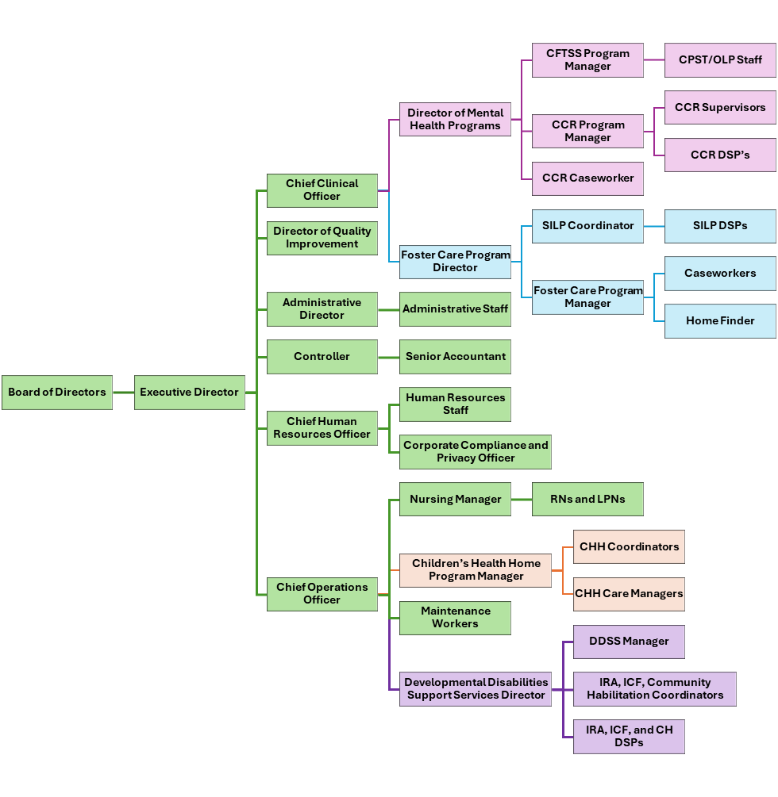

Purpose
TRACS is committed to fostering a culture of quality, operationalized through rigorous planning, analysis, and action based on results. This Quality Improvement Plan (QIP) is based on key areas that are aligned with the quality focus of TRACS, including but not limited to Bureau of Program Certification reviews, internal audits, quality of life and satisfaction levels of individuals supported, and quality and satisfaction levels of staff. The QIP will implement outcome-oriented procedures for overseeing the effectiveness of TRACS DDSS programs and improvement activities.

TRACS Quality Improvement System

Roles and Responsibilities
This section details the roles and responsibilities of stakeholders participating in this QIP. Roles and responsibilities are for (a) Quality Improvement Department, (b) Compliance Department, (c) TRACS leadership, (d) the Quality Improvement Committee (QIC), (e) TRACS Board, and (f) TRACS Staff. Each description includes the respective responsibilities, although they are not exhaustive and parties may take on additional QI responsibilities when appropriate.

Quality Improvement Department
The Quality Improvement Department will serve as the lead department for all QI activities, including development, oversight, and management of all QI initiatives, collection, analysis, and synthesis of data, QI reports, supporting and monitoring efforts to address areas for improvement, leading the QIC, and promoting a culture of quality.

Compliance Department
TRACS has an existing, robust, Corporate Compliance program. The Compliance and QI Departments work closely together to avoid redundancy in work and support QI Initiatives. Specifically, the role of the Compliance Department includes oversight of OPWDD operations and regulations, assuring adherence to regulatory policy, management of Corporate Compliance Program, participating in the QIC, and collaborating with the QI Department. The Compliance Department also is responsible for the oversight, investigation, and trending of reportable and significant incidents.

TRACS Leadership
TRACS Leadership provides executive-level oversight of programs, champions QI initiatives, encourages a culture of quality, and supports programs in addressing areas for improvement.

Quality Improvement Committee
TRACS QIC is a subcommittee of the Board that meets quarterly with the goal of ensuring high quality services for all those served by TRACS. The committee members include executive leadership, program directors, Board members, compliance manager, and nursing manager. This committee’s responsibilities include reviewing program data, serving as a forum to brainstorm QI initiatives, solve problems, and develop recommendations, and providing feedback to the Board on all matters related to quality.

TRACS Board
The TRACS Board will serve in an oversight capacity for the QI Program. Their role regarding QI includes participating in the QIC and QI related activities, reviewing QI reports, and approving the OPWDD QIP annually.

TRACS Staff
TRACS staff play a critical role in the development and implementation of this plan. Staff are essential to ensuring timely completion of tasks and delivery of quality services, participating in QI related activities, and leading by example to promote a culture of quality.

Annual Timeline
Focus areas for the QIP are determined by TRACS’ Quality Improvement Committee (QIC) and may be derived from multiple sources, including but not limited to feedback from stakeholders, the agency’s strategic plan, issues identified as opportunities for improvement through surveys, audits, etc. Input from stakeholders may be obtained through a variety of mechanisms such as satisfactions surveys, self-advocacy meetings, and/or other meetings held with stakeholders. Once approved, the Quality Improvement Plan will be made available to stakeholders on the TRACS website.
Generally, goals identified within the QIP will be assessed on an annual basis. Program selected benchmarks will be monitored at least quarterly, reported at the QIC meetings and to the Board thereafter. The current DDSS benchmarks for quarterly assessment are:
- 75% of residential individuals will be successful with at least one of their goals 75% of the time each month.
- 100% of residential individuals will attend annual medical physicals, dental, and vision appointments.
- 85% of staff will demonstrate knowledge of all OPWDD Core Competencies.
Areas of focus and quality goals are expanded upon in the following sections.

Key DDSS Quality Indicators
As part of the continuous quality improvement process, TRACS places focus on:
- Bureau of Program Certification Reviews
- Internal audits
- Quality of life and satisfaction of individual’s served by TRACS
- Quality and satisfaction levels of TRACS staff
- Staffing capacity, recruitment, and retention

Bureau of Program Certification Reviews
Statements of Deficiency (often referred to as SOD) are issued by OPWDD following a site survey in which there is at least one significant deficiency noted during the survey process. SODs are often issued related to medication administration, health concerns, personal allowances, physical plant issues, fire safety, and nutritional guidelines. If a concern does not rise to the level of a SOD, OPWDD will issue verbal recommendations or Exit Conference Deficiencies. When a more serious offence occurs that places individuals who receive services in imminent danger, a 45-day or 60-day letter is issued. These letters are only issued by OPWDD when very serious site specific or system issues that may affect the health or safety of the program participants are identified. These letters require an immediate Plan of Corrective Action to be developed that includes immediate monitoring and systematic responses to the concerns. This Plan of Corrective Action needs to be approved by OPWDD and if a satisfactory response is not received, OPWDD has the authority to close the program or transfer the auspices to another organization.

Ongoing Activities
- On an annual basis, the QI Department will review the results of survey activity to identify trends and make recommendations for improvements. This analysis will be shared with TRACS leadership, program directors, and the QIC.

Goal
The QI Department has not previously monitored the BPC results and will need to review several years of these to assess for trends.
- Goal: Provide high quality DDSS to all individuals supported by TRACS in accordance with regulations.
  - Action: The QI Department will collect, analyze, and trend the last three years of BPC results to inform goals for following QIPs.
  - Data: BPC results from 2023-2026 will be reviewed. Trends will be shared with the QIC alongside results of the annual DDSS QI Program Evaluation.
  - Responsible Party: QI Department

Internal Audits
TRACS Compliance Department conducts a variety of internal audits, including but not limited to, Residential Quality Reviews, Medical Reviews, and Ledger Reviews. Residential Quality Reviews assess master record documentation, individual plans (Life Plans, Staff Action Plans, and Individual Protective Oversight Plans), service documentation, financial ledgers, fire safety, physical plant, and transportation safety. Although financial ledgers are reviewed as part of the Residential Quality Reviews, the Compliance Department also engages in more in-depth Ledger Reviews to ensure that the amount listed on the house ledger is being reconciled and accurate when compared to the bank account and the house account (money on hand). Finally, Medical Reviews assess Medical Administration Records, Direct Support Professional’s Medical Trainings, Nursing Report Records and Medical Appointments.

Ongoing Activities:
- TRACS Compliance Department will continue conducting its regularly scheduled audits.
- TRACS Compliance Department will share all audit results with the QI Department
- On an annual basis, the Director of QI will analyze and trend the past year’s results. This analysis will be included in the annual DDSS QI Program Evaluation and shared with the QIC and TRACS Board.

Goal
Based on the internal audit results of the 2025 DDSS QI Program Evaluation, in 2026 TRACS DDSS program needs to focus on attendance of medical appointments.
- Goal: Ensure individuals within TRACS DDSS residential programs are attending necessary medical appointments.
  - Action: The recently implemented EHR appointment tracking system will be brought up-to-date and updated contemporaneously with appointments.
  - Data: The QI Department will provide monthly reports on missing appointments to TRACS DDSS and Nursing leadership. Results will also be reviewed quarterly with the QIC.
  - Responsible Parties: QI Department, Nursing Manager, and DDSS Director

Quality of life and satisfaction of individual’s served by TRACS
TRACS is committed to providing high quality support services to individuals with intellectual and developmental disabilities. TRACS DDSS services are designed to empower the individual to increase their independence, learn new skills, and participate in the community. TRACS believes that planning and decision-making to achieve these goals is best done in partnership with the individual receiving services, their families, and advocates.
TRACS utilizes person-centered planning (PCP) to develop plans of support. PCP is an ongoing individualized process of service planning that focuses on the unique strengths, preferences, needs, values, capacities, and interests of the individual. This approach to planning empowers individuals and is designed to empower the individual to increase their independence, learn new skills, and participate in the community. PCP is a dynamic process that adapts as the individual and their aspirations evolve.

Ongoing Activities:
- TRACS Compliance Department assesses application of person-centered planning in Residential Quality Reviews.
- With a strong commitment to the quality of life of individuals served, TRACS DDSS leadership established the following quality benchmark which is reviewed monthly and reported quarterly to the QIC: 75% of residential individuals will be successful with at least one of their goals 75% of the time each month.

Goal
Benchmark analysis from 2025, continues to indicate monthly monitoring of the selected benchmark.
- Goal: 75% of residential individuals will be successful with at least one of their goals 75% of the time each month.
  - Action: Provide thorough training to staff on ISPs and how to track goal achievement appropriately.
  - Data: The QI Department will review Individual Monthly Summaries for all individuals served by TRACS residential programs. Analysis will be reviewed. quarterly with the QIC.
  - Responsible Parties: Director of QI, DDSS Director, and Residential Coordinators
With a commitment to quality, TRACS concerns itself with the experience and satisfaction of the individuals served by the DDSS program and their families. To assess this TRACS QI Department conducts a satisfaction survey with these individuals and their families. The satisfaction survey is mailed to the individual or their guardian, with the option of completing it using an electronic QR code. Survey responses are managed using Microsoft Forms. The results of the survey are analyzed by the Director of QI and included along with trends from prior years in the annual DDSS QI Program Evaluation.

2025 Survey Results
The satisfaction survey was completed in October 2025, consisting of 29 multiple choice questions with the response categories of “No”, “Sometimes”, “Yes”, and “N/A”. Questions on the survey attempt to measure the construct of satisfaction regarding (a) interactions with TRACS staff, (b) participation in person centered planning, (c) independence, (d) community engagement, (e) needs being met, and (f) relationships. Unfortunately, participation in the 2025 survey was low, limiting generalizability. Some of the results were:
- 100% of individuals served feel supported by TRACS DDSS staff in meeting their needs, goals, and encouraging relationships with natural supports
- 100% of individuals served feel that engaging in TRACS DDSS programs has made a positive impact on their life.
- 71% of individuals feel that their dreams, interests, preferences, and capacities guide activities and supports.
- 62% of individuals served feel they go to places in the community they find meaningful

Ongoing Activities:
- On an annual basis, a satisfaction survey is completed that offers individuals and their families an opportunity to report satisfaction with various aspects of TRACS services and the quality of those services.

Goal
By satisfaction category, the highest levels of satisfaction related to interactions with TRACS staff and the biggest area for growth was related to community engagement.
- Goal: Provide individuals supported by TRACS DDSS residential programs with more opportunities for community engagement to meet their needs and interests.
  - Action: Ensure individuals have regular access to the community.
  - Data: The QI Department will review Individual Monthly Summaries each month for discussion of community outings. This data will be synthesized and shared with the QIC quarterly with a formal trend analysis included in the annual DDSS QI Program Evaluation.
  - Responsible Parties: Director of QI, DDSS Director, and Residential Coordinators
Historically, the survey was a single document, and families were encouraged to complete it with the individual being served. However, feedback from families suggested that the survey was difficult to explain to individuals being served. Beginning in 2026, TRACS will utilize two surveys, one for individuals being served and the other geared towards perceptions and satisfaction of the individual’s family or guardian. See Appendix A for a copy of the survey to be used in 2026, subject to change if deemed necessary.

Quality and satisfaction levels of TRACS staff
As part of the quality improvement initiatives Toomey conducts an annual staff survey. The goal is to better assess the delivery of services since the satisfaction of staff in their current positions may impact the way they interact with the individuals they serve. This may be similarly impacted by the sense of support staff receive from their supervisor and team. Finally, staff training levels impact their ability to provide quality care in accordance with OPWDD Core Competencies and the Code of Ethics.

2025 Staff Survey Results
The staff survey was completed in May 2025, distributed via email to all staff. A blank copy of the survey can be found in Appendix B. There was moderate participation from TRACS DDSS staff, improving generalizability of the results. Some of the most positive responses included:
- 90% were satisfied with the work they do
- 84% felt that the mission of TRACS makes their job feel important
- 84% of staff feel they can meet the needs of the clients they work with most of the time
- 79% of staff stated that the best part of their job is the individuals they support
While some of the challenges TRACS DDSS staff identified included:
- 53% of staff identified the most challenging part of their job as issues with coworkers or staffing turnover
- 58% of staff were satisfied with the amount of recognition they receive on the job
- 58% of staff were satisfied with the amount of ongoing training opportunities
- 47%-64% of staff were satisfied various aspects of support received from their supervisor
Follow-up on results related to DDSS staff knowledge of OPWDD Core Competencies and Code of Ethics found that DDSS staff had not been trained on Core Competencies in several years.

Ongoing Activities
- On an annual basis, a staff satisfaction survey is completed to assess satisfaction with general work areas, training, support from supervisor, and administration as well as assessing knowledge of TRACS’ mission and utilization of best practices.

Goals
For 2026, TRACS DDSS will be focusing on two key areas for improvement identified by the staff survey results, supervision and training. These two areas have been selected with the specific intention of enhancing the quality of TRACS DDSS staff.
- Goal: Ensure TRACS DDSS staff feel supported by their immediate supervisor.
  - Action: TRACS DDSS leadership will provide coordinators with guidance and tools to improve their approach to supervision. They will also monitor that regular team meetings are occurring in each program.
  - Data: TRACS DDSS leadership will share supervision supports provided to coordinators and report to the QIC each quarter on which programs held team meetings.
  - Responsible Party: DDSS Director

- Goal: Enhance the quality of TRACS DDSS staff through comprehensive training on OPWDD Core Competencies.
  - Action: TRACS DDSS leadership will train new staff on OPWDD Core Competencies during orientation. All current staff will be trained on OPWDD Core Competencies by June 2026, and it will be included in annual refresher trainings that occur in the fall moving forward.
  - Data: TRACS DDSS leadership will track who has completed OPWDD Core Competency training and report on this each quarter to the QIC.
  - Responsible Party: DDSS Director

Staffing capacity, recruitment, and retention
Leadership at TRACS have the ability to continually assess the adequacy levels of staffing levels and staff performance. Appropriate mechanisms are in place to address deficiencies as they arise. TRACS developed a Recruitment and Retention Workgroup in response to the 2024 Staff Survey results that continues to function as the responsible party for implementing action-based activities to address staffing capacity, recruitment, and retention.

Ongoing Activities
TRACS Leadership, the Recruitment and Retention Workgroup, and the Human Resources Department engage in a number of ongoing activities pertaining to staffing. The following activities are those that are shared with QIC on a quarterly basis.
- Monitoring retention and turnover rates
- Monitoring recruitment and retention activities

Goal
- Goal: Improve the retention of staff through strengthening their connection to the agency, creating opportunities for advancement, and providing additional supports.
  - Actions: TRACS’ recruitment and retention workgroup has implemented several initiatives to improve retention. These include but are not limited to staff anniversary bonuses, Pathway to Promotion training series, and employee recognition activities such as Employee Spotlight (a monthly highlight of one nominated employee who goes above and beyond) and a monthly staff newsletter.
  - Data: Retention and turnover data will be reviewed quarterly at QIC meetings, as will any additional retention activities planned by the workgroup.
  - Responsible Party: Recruitment and Retention Workgroup, Human Resources Department, QIC

Summary of 2026 QI Goals
- Provide high quality DDSS to all individuals supported by TRACS in accordance with regulations.
  - The QI Department will collect, analyze, and trend the last three years of BPC results to inform goals for following QIPs which will be reported in the annual DDSS QI Program Evaluation.

- Ensure individuals within TRACS DDSS residential programs are attending necessary medical appointments.
  - The recently implemented EHR appointment tracking system will be brought up-to-date and updated contemporaneously with appointments by the DDSS Director and Nursing Manager, with oversight from the QI Department and QIC.

- 75% of residential individuals will be successful with at least one of their goals 75% of the time each month.
  - The DDSS Director will provide thorough training to staff on ISPs and how to track goal achievement appropriately and the Director of QI will continue reviewing Individual Monthly Summaries to assess progress.

- Provide individuals supported by TRACS DDSS residential programs with more opportunities for community engagement to meet their needs and interests.
  - TRACS DDSS leadership and coordinators will ensure individuals have regular access to the community, assessed by the QI Department through a review of Individual Monthly Summaries.

- Ensure TRACS DDSS staff feel supported by their immediate supervisor.
  - TRACS DDSS leadership will provide coordinators with guidance and tools to improve their approach to supervision. They will also monitor that regular team meetings are occurring in each program and report on these actions quarterly to the QIC.

- Enhance the quality of TRACS DDSS staff through comprehensive training on OPWDD Core Competencies.
  - TRACS DDSS leadership will train new staff on OPWDD Core Competencies during orientation. All current staff will be trained on OPWDD Core Competencies by June 2026, and it will be included in annual refresher trainings that occur in the fall moving forward.

- Improve the retention of staff through strengthening their connection to the agency, creating opportunities for advancement, and providing additional supports.
  - TRACS’ recruitment and retention workgroup has implemented several initiatives to improve retention. These include but are not limited to staff anniversary bonuses, Pathway to Promotion training series, and employee recognition activities such as Employee Spotlight (a monthly highlight of one nominated employee who goes above and beyond) and a monthly staff newsletter. Continued efforts in this area will be made by the recruitment and retention workgroup.

QIP Evaluation
The QIP will be revised annually by TRACS’ Leadership, the QI Department, and the QIC. After approval from each of these stakeholder the plan will be presented to TRACS Board for approval. If significant changes need to be made to the QIP before the annual Board approval a special amendment vote will be held. One approved by the Board, TRACS will post the QIP on its webpage to ensure all stakeholder have access to it.
The QI Department will take the lead on collecting, analyzing, and trending all data outlined in the QIP in the annual DDSS QI Program Evaluation. This report will also contain recommendations based on the evaluation results which inform the next year’s QIP. QI Program Evaluation results will also be shared with TRACS’ Board of Directors on an annual basis.
Since TRACS has separate Compliance and QI Departments there is often crossover in the type of work being done and which requirements each party satisfies. To minimize overlap and the duplication of work some OPWDD quality standards are being sufficiently monitored, reviewed, and reported on by TRACS’ Compliance Department. The Compliance Department has representation on the QIC and is able to inform the committee on applicable standards. A clear review of the primary responsible party for each OPWDD Agency Quality Performance (AQP) Standard can be found in Appendix C.

Appendix A: Satisfaction Surveys

Individual Survey
The following survey asks about your experiences in Toomey’s program and with Toomey’s staff. These questions ask about your life. We want to know the good things and the things that could be better. We will ask questions about the services you receive, how you are treated, things you like to do, and the role of important people in your life. If you have any questions about the survey contact Julia Blackwell, Director of Quality Improvement, at (315) 530-1920
Please respond to the following questions:
 | No | Sometimes | Yes
- Do you like the home you live in? | ☐ | ☐ | ☐
- Do you have privacy when you want it? | ☐ | ☐ | ☐
- Can you have visitors when you want? | ☐ | ☐ | ☐
- Can you eat your food and snacks whenever you want? | ☐ | ☐ | ☐
- Do you get to do the things you want in the community? | ☐ | ☐ | ☐

Think about the staff you work with at Toomey as you answer the following questions:
 | No | Sometimes | Yes
- Do Toomey staff meet your needs? | ☐ | ☐ | ☐
- Do you feel Toomey staff respect you? | ☐ | ☐ | ☐
- Do you feel Toomey staff listen to you and your concerns? | ☐ | ☐ | ☐
- Do you participate in planning or making choices for your life? | ☐ | ☐ | ☐
- Do you like the way Toomey staff support you? (i.e. personal care, communication, etc.) | ☐ | ☐ | ☐

- Is there anything else you would like to share or explain your responses to the questions above?
________________________________________________________________________________________________________________________________________________________________________________________________________________________________________________________________________
Thank you for your participation!

Family or Advocate Survey
We are asking you to participate in this survey to help improve our services. As a valuable support of a person we serve in our Developmental Disabilities Support Services your perception of how services are going is integral to Toomey’s ongoing quality improvement initiatives.
Below you will find a survey for yourself. On the other piece of paper in this envelope is a survey for the individual being served by Toomey. The Individual survey should only be completed with the person receiving services, to the best of their ability with your assistance. If you are unable to do the Individual Survey with the person receiving services than please leave it blank and only return the survey below. If you have any questions about the survey contact Julia Blackwell, Director of Quality Improvement, at (315) 530-1920.
Please respond to the following statements about your interactions with Toomey staff:
 | No | Sometimes | Yes
- Toomey staff listen to my concerns and take them seriously. | ☐ | ☐ | ☐
- Toomey staff answer my questions quickly. | ☐ | ☐ | ☐
- Toomey staff keep me informed about my loved one and relevant agency matters. | ☐ | ☐ | ☐
- Toomey staff include me in planning. | ☐ | ☐ | ☐
- Toomey staff support my participation in my loved one’s life. | ☐ | ☐ | ☐

Please respond to the following questions on behalf of your loved one receiving services at Toomey. For conciseness your loved one will be denoted as PRS, Person Receiving Services, in the following questions:
 | No | Sometimes | Yes
- Toomey staff help support PRS to meet their needs and goals. | ☐ | ☐ | ☐
- Toomey staff respect PRS. | ☐ | ☐ | ☐
- PRS dreams, interests, preferences, and capacities guide their activities and supports. | ☐ | ☐ | ☐
- PRS has friends and opportunities to form relationships. | ☐ | ☐ | ☐
- PRS goes to places in their community that they find meaningful. | ☐ | ☐ | ☐
- Staff at Toomey are trained in and follow PRS treatment plans. | ☐ | ☐ | ☐
- PRS participates in planning activities routinely. | ☐ | ☐ | ☐
- Engaging in Toomey Services has made a positive impact on PRS life. | ☐ | ☐ | ☐
- How would you rate the overall quality of Toomey’s Developmental Disability Support Services?
- Poor | - Fair | - Good | - Excellent

- How would you rate the effectiveness of Toomey staff?
- Poor | - Fair | - Good | - Excellent

- Do you know who to reach out to at Toomey is you have a question or concern?
- Yes | - No

- Is there anything else you would like to share or explain your responses to the questions above?
________________________________________________________________________________________________________________________________________________________________________________________________________________________

- Toomey is committed to providing quality services to the individuals we serve. To better do this we have been redesigning our quality improvement process and satisfaction surveys. If you have any feedback about the new format of this survey we would greatly appreciate it:
________________________________________________________________________________________________________________________________________________________________________________________________________________________

If you would like to discuss any issues regarding your satisfaction with care, please call Tom Greene, Program Director, at (315) 362-7623.
Thank you for your participation!

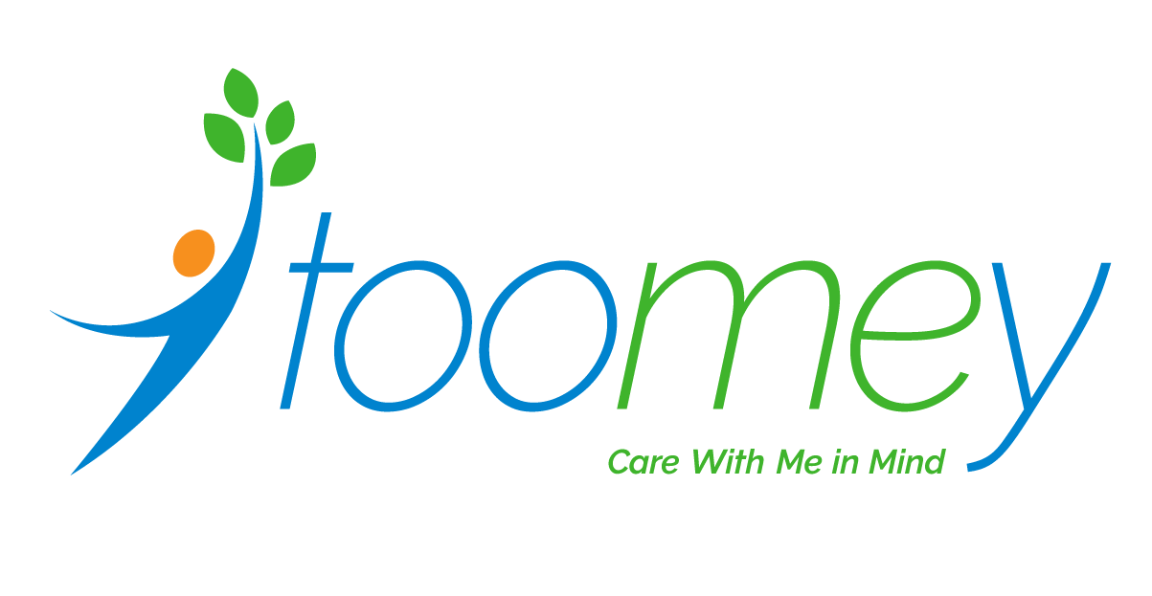
Appendix B: Staff Survey
We are asking you to participate in this survey as a part of the quality improvement program at Toomey. We want your honest opinions and your answers will be kept confidential. Please contact Julia Blackwell at (315) 530-1920 with any questions. Thank you for your participation!
- What is the best part about your job?
____________________________________________________________________________________
- What is the hardest part about your job?
____________________________________________________________________________________
- Please indicate how satisfied you are with the following aspects of your job:
 | Very Dissatisfied | Dissatisfied | Satisfied | Very Satisfied
The type of work you do
The amount of recognition you receive on the job
The workplace culture at Toomey
Your ability to have a work/life balance

- How long have you worked at Toomey?
  - {Less than one year, 1-2 years, 3-5 years, 6-10 years, More than 10 years}
- To the best of your knowledge, what are the core values of Toomey?
  - {Empowerment, Integrity, Growth, Diversity, Compassion, Appreciation, Wellness}
- Please rate your level of agreement: The mission or purpose of our company makes me feel my job is important.
  - {Strongly agree, Agree, Disagree, Strongly disagree}

Training and Best Practices
- Please indicate how satisfied you are with the training and development you receive:
 | Very Dissatisfied | Dissatisfied | Satisfied | Very Satisfied
The initial training you receive when hired
The amount of on-going training and development opportunities

- Which of the following types of training would you be most interested in taking if Toomey offered them? (Please select up to 3)
  - Role specific trainings (Ex: reviewing the expectations of your role and task guidance)
  - People Skills Trainings (Ex: Effective Communication, Critical Thinking, Fostering Collaboration, etc.)
  - Advancement Trainings (Ex: A series of trainings for promotion)
  - Cross Training (Ex: learning about other departments at Toomey)
  - Self-Care Trainings (Ex: Work life balance, Stress Mitigation, etc.)
  - Compliance and Ethics Trainings
  - Supervision Trainings (Ex: Tools for effective supervision)
  - Best Practice Trainings (Ex: Trauma-informed care, EBPs, etc.)
- What program are you a part of?
- Children’s Health Homes
- CFTSS (OLP and CPST)
- OPWDD Services (skips Q10)
- Foster Care Services
- Children’s Community Residence
- Nursing
- General or Administrative
- A best practice is a procedure or set of guidelines that has been shown by research and experience to produce optimal results. What best practices is your program currently utilizing? Note that while some best practices in this list are shared across the agency, others are unique to the services we offer.

- Person Centered
- Trauma Informed
- Kinship Care
- Strength based services
- Building positive relationships
- Practicing self-care
- Culturally responsive care
- Promoting self-advocacy and self-determination
- Family focused
- Self-Direction
- Use of evidence based practices (DBT, CBT, etc.)
- Respecting dignity and choice
- Other: (List Here)

DDSS Core Competencies (Only for DDSS Staff)
- Which of the following are OPWDD Core Competencies?
- Practicing Self-Care
- Putting People First
- Demonstrating Professionalism
- Cognitive Behavioral Therapy
- Get into the Community
- Trauma Informed-Care
- Please name the OPWDD Core Competency Areas you know off the top of your head.
- Which of the following are key aspects of the OPWDD Code of Ethics?
- Providing person-centered supports
- Demonstrating integrity
- Maintaining confidentiality
- Advocating for justice, fairness, and equity
- Respecting dignity and choice
- Building positive relationships
- Promoting self-determination
Supervision and Support
- My immediate supervisor…
 | Strongly Disagree | Disagree | Agree | Strongly Agree
Gives me the leadership and direction I need to be successful
Regularly communicates what is going on in the program
Is open to receiving feedback from me
Acknowledges when I do my work well
Tells me when my work needs improvement
Models Toomey’s values in their work

- How often are you able to meet with your supervisor to discuss concerns?
  - {Weekly, Bi-weekly, Monthly, Seldom, Never, Other (please specify)}
- How frequently does your team meet for staff meetings?
  - {Weekly, Bi-weekly, Monthly, Seldom, Never, Other (please specify)}
Agency Questions
- Please rate your level of agreement with the following statements about your work.
 | Strongly Disagree | Disagree | Agree | Strongly Agree
I have the resources needed to do my job
I can meet the needs of the clients I serve most of the time
When decisions are made that affect my work, I have the opportunity to provide input.

- What do you like most about working at Toomey?

- Toomey Leadership is actively working on ways to show our appreciation for all the hard work our staff do each day. Which of the following ideas would you be most interested in seeing implemented?
- Work anniversary bonuses
- Food at staff meetings or supervision
- Discounted memberships (Ex: Gyms, Zoo, etc.)
- Agency wide social events
- Program shout-outs
- Toomey swag
- Organized self-care opportunities

- What word would you use to describe working at Toomey?

- Is there anything else you would like to share? ___________________________________________

Appendix C: OPWDD AQP Standards
A. Person Centered Planning and Service Delivery: Every person's unique strengths, needs, goals, and preferences concerning their life dictate the effective planning and implementation of services and supports. |  | Key Indicator and Department Responsible for Oversight
A.1. Competent person centered planning is occurring, in a manner which is free from conflict of interest.
 | A.1.a. Individual desired goals and outcomes, preferences, needs and safeguards are effectively identified and prioritized. | Residential Quality Reviews (ISPs) conducted by the Compliance Department.
 | A.1.b. People important to/chosen by the Individual are included in service planning, with the Individual deciding how much control they have over the planning process.
 | A.1.c. Individuals are supported to make informed choices (allowing dignity of risk) and understand the impact of their decisions in planning their services.
 | A.1.d. Self-direction of services is offered.
 | A.1.e. The person centered planning process results in a personalized service/support plan.
A.2. Planned supports and services are reviewed for effectiveness and revised as needed.
 | A.2.a. Dialog between the Individual and their circle of support/planning team is used to identify needed modifications to the plan on an ongoing basis and in planning meetings. | Residential Quality Reviews (ISPs) conducted by the Compliance Department.
 | A.2.b. The Individual’s plan is reviewed at least semi-annually and as needed and/or desired by the person receiving services.
 | A.2.c. The individual’s plan is reviewed at a time and location convenient to the individual.
 | A.2.d. The individual’s plan is modified when needed.
 | A.2.e. Progress toward the achievement of goals, priorities and outcomes is reviewed.
 | A.2.f. The mechanism and resources for delivery/provision of supports are reviewed to ensure they are the most effective and integrated per the individual’s needs and preferences.
A.3. Services and supports are effectively delivered toward achieving desired outcomes.
 | A.3.a. Supports are implemented per the Individual’s identified needs, preferences and safeguards identified in his/her plan. Provision of supports results in advancement towards desired goals, outcomes. | Residential Quality Reviews (ISPs) conducted by the Compliance Department.
 | A.3.b. Use of Community and/or natural supports are maximized in the delivery of services.
 | A.3.c. Supports result in advancement toward or achievement of the Individual’s’ goals and outcomes.
 | A.3.d. Services and supports are delivered in the most functional and independent settings according to the Individual’s goal or outcome.
 | A.3.e. Individuals receive all services and supports in the most integrated settings appropriate to their needs and desired outcomes.
 | A.3.f. Individuals are encouraged and supported to choose services, activities and supports.
 | A.3.g. Supports and services enable a mix of structured and unstructured activities, consistent with the person’s expressed preferences, resulting in a lifestyle that is as similar as possible to the same degree as others in their community. | Individual Monthly Summaries are reviews by the QI Department monthly.
 | A.3.h. Individuals are supported and encouraged to advocate for their desired life and to enhance personal self-advocacy skills. | Residential Quality Reviews (ISPs) conducted by the Compliance Department.
 | A.3.i. Important information and events that impact Individuals are effectively communicated and coordinated among different supports, providers and environments important to the person. | Individual Monthly Summaries are reviews by the QI Department monthly.
B. Rights, Health, and Protections: Every person’s rights, health and welfare are safeguarded and monitored based on informed and expressed choices of the Individual.
B.1. Individual Rights are protected.
 | B.1.a. Individuals are treated respectfully and fairly and according to their rights. | Annual Individual and Family Surveys conducted by the QI Department.
 | B.1.b. Individuals are supported to exercise and advocate for their rights and responsibilities. | Grievance policy overseen by the QI and Compliance Departments.
 | B.1.c. People are free from unnecessary restrictive or intrusive interventions and limitations. | Residential Quality Reviews (ISPs) conducted by the Compliance Department.
 | B.1.d. People receive positive behavior supports that promote behaviors known to result in a richer quality of life.
 | B.1.e. People are treated with psychoactive medications for mental health needs in a manner consistent with national standards of care. | Medical Quality Reviews conducted by the Compliance Department.
 | B.1.f. The organization implements policies and procedures that promote and protect people’s rights. | Primarily maintained and tracked by the Compliance Department. (EG: Client Bill of Rights, Grievance Policy, Incident Reporting, etc.)
 | B.1.g. The organization's policies and procedures facilitate positive behavior supports and this is evidenced by the people's experiences of those supports. | Individual Monthly Summaries and Individual Surveys are reviewed by the QI Department.
 | B.1.h. The organization upholds required due process requirements. | Monitored by the Compliance Department.
B.2. Individuals are free from abuse, neglect, mistreatment and exploitation.
 | B.2.a. Support staff prevent, recognize and report allegations of abuse, neglect, mistreatment, and exploitation, and other reportable incidents, occurrences and events in accordance with regulation and agency policy. | The Compliance Department maintains primary responsibility for Incident Reporting, including collecting reports, conducting investigations, and quarterly reviews.  The Director of QI chairs the monthly Incident Review Committee meetings.
 | B.2.b. The organization implements clear policies and procedures for the management of reportable incidents, occurrences and events which are current, adequate, and consistent with regulatory requirements.
 | B.2.c. The organization consistently identifies, implements and documents appropriate and sufficient immediate protective actions in accordance with the situation which protects individuals and minimizes the likeliness of reoccurrence.
 | B.2.d. The organization implements thorough and appropriate responses to reported abuse and other incidents that it will minimize the chance of reoccurrence for the involved individual(s) and all individuals supported by the organization.
 | B.2.e. Investigations of incidents and occurrences are consistently completed timely (IRC needs to be notified and review w/in 30, and 60 days to complete), are comprehensive, reach reasonable conclusions based on the factual findings, and result in recommendations which are appropriate, systemic, and sufficient.
 | B.2.f. The organization reviews and analyzes trends and potential risks related to reported abuse/neglect, injuries, deaths and other occurrences/ incidents, to continually improve agency systems to prevent future problems.
 | B.2.g. The organization's Incident Review Committee operates in accordance with regulatory requirements for membership and activities conducted.
 | B.2.h. The organization implements policies and procedures/activities that define, prohibit, and prevent abuse, neglect, mistreatment and exploitation. | Primarily maintained and tracked by the Compliance Department. (EG: Agency Handbook, Program P&P Manual, Staff Training, etc.)
B.3. Individuals access quality health care and clinical care.
 | B.3.a. People have access to and consistently receive professional medical and dental services for acute and routine health care in integrated settings according to their needs and informed choices. | Medical Quality Reviews conducted by the Compliance Department.  EHR Appointment Tracking system monitored monthly by the QI Department.
 | B.3.b. People have access to and consistently receive needed professional clinical services in integrated settings in accordance with their informed choices.
B.3.c. People receive needed routine care or support to maintain/improve their health at home and during daily routines in accordance with their informed choices.
i.e., treatments and care, monitoring of chronic conditions, and identification of and monitoring of acute conditions)
 | B.3.d. People receive needed medications and treatments safely in accordance with their informed choices.
 | B.3.e. People's health is supported through competent oversight of health care and health care supports, as needed.
 | B.3.f. People's nutritional and dietary needs are appropriately and safely met in accordance with their informed choices.
 | B.3.g. Individuals are supported to manage their own health care.
 | B.3.h. Healthy lifestyles are encouraged and supported. | Individual Monthly Summaries are reviews by the QI Department monthly.
 | B.3.i. Medical/health emergencies are timely and effectively addressed. | Medical Quality Reviews conducted by the Compliance Department.
 | B.3.j. The organization evaluates its effectiveness in the promotion of health care services, supports, and objectives. | Individual Monthly Summaries are reviews by the QI Department monthly.
B.4. Fire Safety and Emergency Planning needs are met.
 | B.4.a. People's needed supports/safeguards related to fire safety are assessed, discussed during service and support planning, and identified in the support plan. | Residential Quality Reviews conducted by the Compliance Department.
 | B.4.b. People receiving supports are provided opportunities to review, learn and/or practice actions to take in a fire emergency according to their support plan.
 | B.4.c. Environments/Settings have effective alarm, detection and protection equipment as needed by the individual and according to their support plan, and as required by the setting.
 | B.4.d. The organization has clear written procedures to support individual safety including effective fire evacuation plans, fire prevention plans, and related training.
 | B.4.e. The organization has individualized/site specific emergency plans for non-fire emergencies.
B.5. Sites and facilities where Individuals are supported are clean, safe and free from hazards.
 | B.5.a. Physical environments are consistently maintained and clean. | Residential Quality Reviews conducted by the Compliance Department.
 | B.5.b. People are supported in sites that meet their individualized needs/preferences for health, safety, comfort and independence.
B.6. Personal Funds needs are met and safeguards are in place.
 | B.6.a. Individuals have access to their personal funds according to preferences and needs. | Residential Quality and/or Ledger Reviews conducted by the Compliance Department.
 | B.6.b People’s personal funds are safeguarded.
 | B.6.c. People's personal funds are sufficient to meet their needs.
 | B.6.d. People's personal funds are managed effectively.
C. Natural Supports, Community Connections, and Integration: Individuals are supported in establishing natural supports, meaningful relationships and community connections in the most integrated settings appropriate to their needs, based on their informed and expressed choices.
C.1. Organizational practices facilitate and promote the establishment, maintenance and optimization of Natural Supports.
 | C.1.a. The organization facilitates the creation, development, and continuation of natural support networks for individuals per their wants. | Residential Quality Reviews (ISPs) conducted by the Compliance Department.
 | C.1.b. The organization implements policies and practices for the regular inclusion of natural supports in individual service planning and delivery per the person's preferences.
 | C.1.c. The organization implements policies and practices for regular and timely communication with a person's natural supports regarding issues and concerns, per the person's preferences. | Adherence to the P&P manual is overseen by the DDSS Program Director
C.2. Organizational practices facilitate involvement in the community and community networks.
 | C.2.a. The organization supports people served to develop meaningful relationships, community connections and social, cultural and spiritual networks. | Individual Monthly Summaries are reviews by the QI Department monthly.
 | C.2.b. The organization works collaboratively with other community entities in the development, implementation, and provision of services that respond to the diversity of supported populations. | Participation in Local Director’s Collaboratives, CNY Compliance, and IPAs by the Executive Director, Compliance Officer, and Director of QI
 | C.2.c. The organization implements community outreach, working to build community alliances that result in increased opportunities for people supported.
 | C.2.d. The organization supports employees/volunteers to develop social networks and community connections toward the goal of increased opportunities for persons supported to build their own social networks and community connections. | Cultivating relationships with local businesses/restaurants is done by the Executive Director and DDSS Director
C3. Person Centered Reviews indicate that individuals are provided Natural Supports, and experience meaningful relationships and community connections per their interests, needs and preferences. |  | Annual Individual and Family Surveys conducted by the QI Department.
D. Workforce: The workforce is stable and competent.
D1. The organization's hiring practices are in accordance with OPWDD and Agency requirements.
 | D.1.a. The organization hires staff according to OPWDD requirements, who meet job qualifications and contribute to people's diverse support needs and interests. | Human Resources and the DDSS director uphold this standard. Oversight is by the Compliance Department in the form of Personnel Record Reviews.
 | D.1.b. There is a mechanism to ensure that people receiving supports, and/or their advocates, are invited to have an active role in the hiring process to include candidate recruitment, interview and hiring decisions. | Secondary interviews of qualified candidates are conducted in the house they will likely work in.
D2. The organization assigns staff appropriately.
 | D.2.a. The organization allocates staff in sufficient numbers to meet people's health and safety needs, and accommodate their diverse individualized goals, priorities, interests, and abilities. | Human Resources and the DDSS Director uphold these standards. Actions which are overseen by the Chief Operating Officer and Executive Director.
 | D.2.b. The organization and individual(s) work in partnership to select and assign staff that have the necessary skills/training to meet people's needs and their diverse individualized goals, interests, and abilities.
 | D.2.c. The organization has a system in place to monitor staff vacancy rates and staff retention and responds accordingly.
D3. The workforce is supported, trained and developed to achieve the agency’s mission.
 | D.3.a. The organization's training policies, procedures and practices meet OPWDD regulatory requirements. | The Executive Director oversees the P+P manual.
 | D.3.b The organization provides ongoing supervision and training/learning experiences to develop staff ability to identity, understand, facilitate and support the diverse personal outcomes of people they support. | Human Resources, Compliance, and the DDSS Program Director oversee required trainings.
 | D.3. c. The organization provides ongoing staff development opportunities to staff at all levels of the organization.
 | D.3.d. The organization implements mechanisms that that support and maximize retention and continuity of quality staff. | The Recruitment and Retention Workgroup is responsible for these activities.
 | D.3.e. The organization develops and implements ongoing workforce communication, engagement and support mechanisms to improve workforce quality indicators.
 | D.3.f. Formal and informal performance evaluations/ feedback systems promote engagement, commitment and Career progression for all employees. | Human Resources initiates and monitors annual performance evaluations.
D4. The agency implements OPWDD DSP core competencies.
 | D.4.a. The agency implements DSP core competencies in accordance with OPWDD guidelines. | Training logs and staff survey results reviewed by the QI Department
 | D.4.b. Staff demonstrate core competencies for their roles and in performance of their job functions.
E. Agency Mission, Operations, Leadership and Governance: The organization’s mission, vision, and values promote attainment of personal outcomes. Business, administrative and support functions promote personal outcomes. The organization implements sound organizational and fiscal practices.
E1. Mission: The organization’s mission, vision, and values promotes attainment of personal outcomes.
 | E.1.a. The organization has a clear mission that align its services and supports with achievement of individuals’ valued outcomes. | The Executive Director monitors adherence to TRACS Mission and Strategic Plan
 | E.1.b. The organization's mission, goals and objectives support those of OPWDD.
 | E.1.c. The organization's mission and goals are communicated to all people receiving supports and services and their families/advocates; all level of staff; and the governing body. | Staff Survey data and Board Minutes are reviewed by the QI Department annually.
 | E.1.d. The organization maintains a knowledge management system that facilitates organizational learning. | Human Resources maintains Litmos.
E2. Operations: The organization implements sound fiscal practices. Business, administrative and support functions promote personal outcomes.
 | E.2.a. Key Financial Ratios are Acceptable and there are no outstanding liabilities as a result of audits regarding: Assets/liability, Income-expenses, and Surplus vs. net assets. | The Finance Department provides oversight to each of the objectives through program financial audits, CFR/CFS, and monthly summaries presented to the Board Finance Committee.
 | E.2.b. The organization has sound financial systems (budgeting, accounting, and reporting) that provide meaningful data and analysis.
 | E.2.c. There is appropriate oversight of Medicaid Billing to assure that claims are coded and billed in accordance with requirements. (HCBS waiver assurance).
 | E.2.d. Consolidated Financial Reports (CFR) and Certified Financial Statements (CFS) are completed appropriately and submitted on time.
 | E.2.e. The organization maintains an adequate internal control framework.
E3. Leadership and Accountability: The organization implements systems that result in the delivery of effective supports and services.
 | E.3.a. The organization implements systems to review and monitor its processes to facilitate compliance with applicable NYS and Federal requirements. | Audits conducted by the Compliance Department
 | E.3.b. The organization implements systems to review and monitor its processes to facilitate implementation of quality supports and services in support of people's desired outcomes. | Annual QI Program Evaluation conducted by the QI Department
 | E.3.c. The organization has governance, human resource, financial, and legal policies and procedures. | Bylaws, HR P&P, and Finance P&P maintained by Executive Director.
 | E.3.d. The organization implements conflict of interest policies and procedures. | Conflict of Interest Policy overseen by the Compliance Department
 | E.3.e. The agency leadership engages all membership/stakeholders in the implementation of the mission and goals of the agency. | Strategic plan maintained by the Executive Director.
 | E.3.f. The organization actively recruits, promotes, and supports a culturally and linguistically diverse leadership that is responsive to the population in services. | Agency hiring policy and practice overseen by Chief HR Officer.
E4. Governance: Agency’s governing Board provides active oversight to ensure effectiveness of executive staff and the agency in carrying out its Mission.
 | E.4.a. The Board has an appropriate framework to exercise active governance. | Board Bylaws maintained by the Executive Director.
 | E.4.b. The board has a mechanism for active representation of people supported in agency governance and decision making. | Toomey is working to develop this mechanism.
 | E.4.c. The Board demonstrates oversight of the Executive Director including adherence to executive compensation requirements. | Annual Board evaluation of the Executive Director which is monitored by Human Resources.
 | E.4.d. The Board has adequate diversity of the appropriate skills and cultural competency to make decisions in alignment with the organization’s mission. | The Board Development Committee and Executive Director oversee Board Procurement and Training.
 | E.4.e. The Board provides fiscal direction and oversight. | Evidence by the Board and Finance Committee minutes which are reviewed by the QI Department.

F. Quality Improvement
The organization acts to improve its effectiveness in the support individuals' quality of life.
F1. Quality Plan: The organization has a written plan that identifies standards, goals, and objectives and the actions necessary to meet them.
 | F.1.a. The quality improvement plan integrates the domains and factors outlined in this quality matrix and any other areas evidenced to be important to people supported by the agency and OPWDD priority areas (e.g. person-centered mechanisms/assessments, information from satisfaction surveys, employment, etc.) | TRACS Quality Improvement Plan which is annually updated by the QI Department and approved by the Board.
 | F.1.b. The quality improvement plan includes a statement of the goals and objectives for the agency’s delivery of high quality services.
 | F.1.c. The quality improvement plan includes standards related to individual/family satisfaction with services and supports, and agency response to people's concerns and complaints as needed.
 | F.1.d. The quality improvement plan includes roles, responsibilities and processes to address quality improvement and regulatory deficiencies.
 | F.1.e. The quality improvement plan includes the description of Quality Improvement actions to be taken during the year.
 | F.1.f. The agency’s quality improvement plan incorporates self-assessment, aggregation, and analysis in an annual progress summary that incorporates the quality improvement actions taken during the year in response to this information.
 | F.1.g. The quality improvement plan is reviewed and approved by the board of directors on at least an annual basis. | The QI Department annually presents the QI Plan for feedback to the Board before approval.
 | F.1.h. There is a system/mechanism for soliciting input from and making the Quality Improvement Plan known to persons supported, staff, agency stakeholders and other interested parties.
F2. Continuous Quality Improvement: The organization's Quality Plan includes a systemic approach to continuous quality improvement.
 | F.2.a. The organization integrates its efforts in quality assurance, quality improvement, and quality of life into an effective, integrated quality management system. | The QI Department is responsible for TRACS Quality Improvement Plan and annual QI Program Evaluation.
 | F.2.b. Continuous Quality improvement activities include the systematic collection and analysis of data related to quality assurance, quality improvement, and individualized quality of life.
 | F.2.c. Continuous quality improvement includes organizational response to findings resulting from QI activities. | Toomey is working to develop a formal mechanism.
F3. Quality Improvement and Quality of Life: The organization's Quality Plan includes measurement, aggregation and analysis of factors related to individuals' needed and desired quality of life.
 | F3a. The organization analyzes data about desired outcomes expressed by people supported to plan for agency goals and strategies that work to improve quality of services and quality of life for the people supported. | Annual QI Program Evaluation conducted by the QI Department

